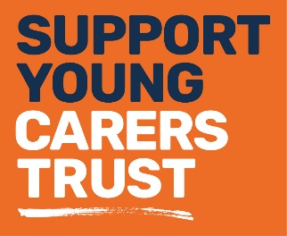

Our services
_____________________________________________
Fact sheet 5: Support for young carers
Young carers are people under the age of eighteen whose caring role may involve them taking on a level of responsibility that is inappropriate for their age or development. Our Young Carers team works with children as young as five years old; we have developed a range of support services which help these young people to have a typical childhood. These include:
Young carers services (5-16 years)
- School liaison programme
- 1:1 emotional support and support planning
- Young carer clubs across the borough
- School holiday events programmes, including all half-term holidays
- Arts projects, fun activities, residential trips and family days

Young carer clubs
Our young carer clubs offer a great range of activities and take place as follows:
- Saturday club
Harlington Young People’s Centre, 10.30am-1:00pm, all year round, 5-9 years /10-18 years on alternate weeks
- Ruislip after-school club
Ruislip Young People’s Centre, 3.30pm-6:00pm, every Wednesday, term-time only, 9-16 year olds
- South Ruislip after-school club
South Ruislip Young People’s Centre, 3.30pm-6:00pm, every Tuesday, term-time only, 9-16 year olds

Young adult carers (16-24 years)
In addition, we now offer support to young adult carers to make the transition from childhood into adulthood – or from school to whatever comes next. We know that young carers are twice as likely to be NEET (not in education, employment or training) than their peers and they do not always enjoy a smooth transition into adulthood. Our N-HANCE transition service offers:
- Support and advocacy through the transition from school to work, apprenticeships or further education
- A personal mentor throughout the process
- A comprehensive programme of training to provide a range of life skills from money management to CV writing
- A social programme with trips, activities and residential trips
- Liaison and links to further education, apprenticeship schemes, local employers, training and volunteering opportunities.
Young adult carers club
Our young adult carers club offers a large range of activities and takes place at;
- Harlington Young People’s Centre
every alternate Tuesday 18:30-21:00 term-time only

Family Support Service
As part of developing a ‘whole family approach’, we now have a service which works with families who are in need of more intensive support. Our Family Support Officer will work with families for between 3-6 months in attempt to tackle particular issues that families are facing.
The support is tailored to the individual needs of each family, and we can work with both young and adult carers alike. Here are some of the aspects we can help with:
- Housing advice and liaison with local housing services
- Education and training support
- Money and benefits advice
- Liaison with schools, colleges, universities and places of work
- Referral to other agencies and projects (i.e. counselling, local targeted programmes for young people etc.
- 1:1 sessions and support planning with young / young-adult carers

For more information about our services please contact us on:
Telephone: 01895 811206
Email: office@carerstrusthillingdon.org
Website: www.carerstrusthillingdon.org

