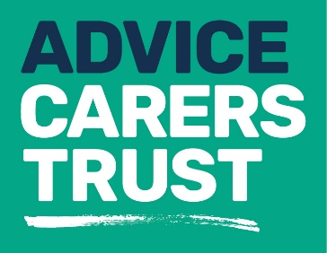
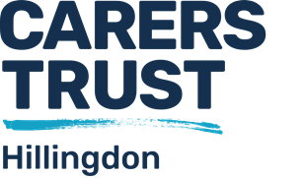

Our services
_____________________________________________
Fact sheet 3: Carers Assessment

What is a carer’s assessment?

- A carer’s assessment is for someone who gives care and support to an adult family member or friend. You do not need the permission of the person you are caring for to request a carer’s assessment.

- A carers' assessment will consider what impact the care and support you provide is having on your own wellbeing and on the rest of your life outside caring.

- It should cover your caring role, your feelings about caring, your physical, mental and emotional health and how caring affects your work, leisure, education, wider family and relationships.

- Having a carers' assessment will not affect whether or not you receive a Carers Allowance.

- Carers Trust Hillingdon will carry out a carer assessment for you if you care for an adult and are over 18 years.

- A needs assessment is an assessment of an adult who may need care and support (the cared for person). The cared for person and their carer may also choose to have a combined assessment, which takes account of both peoples' needs. This would be conducted by a social worker from the London Borough of Hillingdon.

Is a carers' assessment right for me and how do I decide?

- Under a new government act called the Care Act, which came in to force on 1 April 2015, you are entitled to a carers’ assessment. (See fact sheet 14 for more information on the Care Act.) You can ask for this assessment even if the person you care for does not have their own needs assessment.

- Some services that can be provided for the cared for person are accessed through a needs assessment; this includes replacement and/or respite care so you might wish to consider the best route for you.
- Carers Trust Hillingdon Advice team can give you support and information to help you in making this decision.

What can I expect after a carers assessment?

- The information you provide in your carers' assessment will be used to work out the support you need, including individualised information and advice.

- Support might be provided by the council or by a range of community organisations. Carers Trust Hillingdon is the lead provider of all sorts of support for carers (See our range of fact sheets on Our Services, numbers 1-7) and there will almost certainly be something that we can help with.

- There are also a range of more specialist services that we can put you in touch with. For example, if the person you care for has mental health issues, there is specialist support from an expert mental health MIND charity. Our Advice team know what is out there and can discuss these options with you.

- If the person you care for is not in receipt of any care from the council, you will probably be eligible for some replacement care from our colleagues at Harlington Care, who have a well-trained team of carer support staff to enable you to take a few hours break from caring.

Requesting an assessment

For more information about our services please contact us on:

Telephone: 01895 811206
Email: office@carerstrusthillingdon.org

Website: www.carerstrusthillingdon.org

Alternatively, if you would like a combined assessment, a needs assessment for the person you care for, you should contact Hillingdon Social Care Direct:

Email: socialcaredirect@hillingdon.gov.uk

Telephone: 01895 556633 - Monday- Friday, 8am – 6pm
01895 250111 - Out of hours

