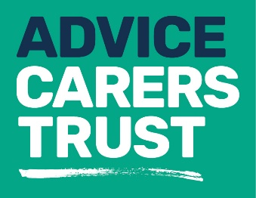

Our services
_____________________________________________
Fact sheet 2: Information and advice
Information and advice for carers is our core business and is a service that is often critical to how carers manage their caring roles. We know that the advent of caring is rarely planned and can happen at any time. It can take years before someone self-identifies as a carer and this can mean essential advice and support doesn’t reach you or reaches you too late.
Information and advice is needed to address different aspects of caring at different times and we make every effort to tailor our support to your individual needs. We believe it is important that you have time to think through your options and make informed decisions about your life alongside your caring role.
Our service offers:
- A drop-in Advice Centre on Uxbridge High Street, which has a wide range of information about support available to carers across Hillingdon

- A borough-wide outreach programme in GP surgeries, Community Centres, Hillingdon Hospital and various public events and information fairs

- Carer Assessments (see Fact Sheet no.3)

- Regular Carer newsletters to update you about support services, new opportunities and changes to the law affecting carers

- Regular updates on our website, Facebook, Twitter, LinkedIn and Instagram

- An annual Carers Conference, Carers Forum and Carers’ Fair

- Our developing range of fact sheets

- Our services are provided in several community languages

- Home visits are available
Our friendly Advice team has successfully claimed close to £2 million in benefit entitlements over the past two years. You can get always get help from our skilled Advisers for:
- Expert welfare benefit advice and help with form-filling
- Support with appeal submission
- Basic debt advice
- Blue Badge applications
- Assistance in accessing care and support
- Advice on housing issues
- Signposting and referral to other services
- Access to hardship grants to help in difficult situations
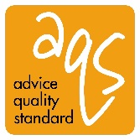
Carers Trust Hillingdon holds an Advice Quality Standard (AQS) quality mark level 2 in Casework, Advice and Guidance.

For more information about our services please contact us on:
Telephone: 01895 811206
Email: office@carerstrusthillingdon.org
Website: www.carerstrusthillingdon.org

