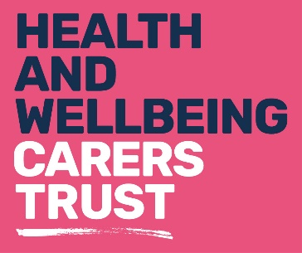

Health matters:
_____________________________________________
Fact sheet 8: Top tips
If you’re looking after someone, it is important to look after yourself too. You matter just as much as the person you care for and looking after your health will mean you will be better able to help them in the longer-term.
Here are a few things you should think about:
- Eat properly
As a carer, eating a balanced diet is essential to provide your body with all the nutrients it needs. A balanced diet will keep your body strong and give you enough energy for yourself and help you to provide the best care for the person you are caring for.

- Exercise regularly
Try to get some exercise when you can, even though time is precious. Carers Trust Hillingdon offer a range of exercise programme’s that are free to carers and that cater for all abilities.

- Make sure you get regular check-ups from your doctor
It is sometimes hard to find the time to visit the doctor for your own health needs but it is important to do so. If you’ve got a symptom you’re concerned about, get it checked out quickly, don’t leave it to get worse.

- Look after yourself emotionally
Caring can be hard sometimes, and many carers can get depressed or anxious. Speak to someone - us, other carers, friends or family members - about how you feel. Tell your doctor if you’re feeling low and ask what help they can give you. Carers Trust Hillingdon also offer a free counselling service.

- Ask others to help
Many people want to help but don’t know how. Give them specific things you need doing and specific times you need them to come; They may well be pleased to be asked.

- Make sure you get a break, even for a few hours
Breaks from caring will help you recharge your batteries. Use this time to follow your own interests if you can, rather than doing chores like grocery shopping. You may be able to get some funding to help you to do this. Speak to us about what’s available or ask for a Carers Assessment.

- Get a good night’s sleep
We understand this is sometimes easy to say and difficult to achieve. However, getting plenty of rest is important to your long-term health and well-being.

- Don’t become isolated or feel alone
Get in touch with other carers or other people with interests similar to yours. If it’s difficult to get out, you could join an online group if you have access to a computer. Contact us to see how we can help.

For more detailed information about topics mentioned here please ask for the following fact sheets in the Health Matters series:
Fact sheet 9 – Health matters: Better sleep
Fact sheet 10 – Health matters: Healthy eating
Fact sheet 11 – Health matters: Managing anxiety and depression
Fact sheet 12 – Health matters: Loneliness and social isolation

For more information on our services please contact us on:
Telephone: 01895 811206
Email: office@carerstrusthillingdon.org
Website: www.carerstrusthillingdon.org

