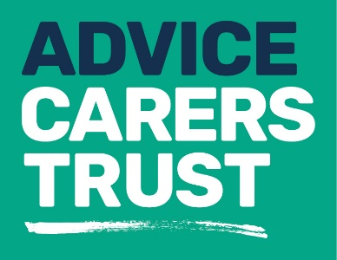
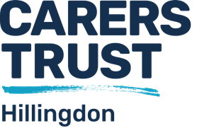

Your rights
_____________________________________________
Fact sheet 14: Debt Helplines
CITIZENS ADVICE BUREAU -  Hillingdon  Telephone: 0344 848 7903  (Calls cost 5p per minute from BT Landline)  www.hillingdoncab.org.uk | DEBT FREE LONDON – DEBT ADVICE  EMAIL: dfl@hillingdoncab.org.uk
MENTAL HEALTH MONEY ADVICE  Telephone: 01895 277304  EMAIL: mentalhealth@hillingdoncab.org.uk | NATIONAL DEBTLINE  Telephone: 0808 808 4000  www.nationaldebtline.org
STEPCHANGE  Telephone: 0800 138 1111  Mon-Fri 8am-8pm  Sat 8am-4pm  www.stepchange.org | ADVICE UK  Money & Debt Advice  Telephone: 0800 043 4050  www.debtadvicefoundation.org
PAYPLAN  www.pay.plan.com/debtadvice | THE MONEY ADVICE SERVICE  Telephone: 0800 138 7777  www.moneyadviceservice.org.uk
THE MONEY CHARITY  www.themoneycharity.org.uk | MY MONEY STEPS  www.mymoneysteps.org
For more information about our services please contact us on:
Telephone: 01895 811206
Email: office@carerstrusthillingdon.org
Website: www.carerstrusthillingdon.org

