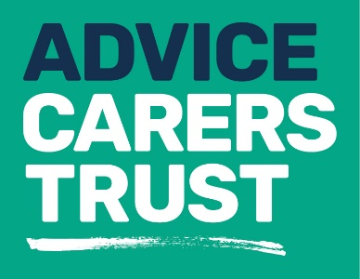

Your rights
_____________________________________________
Fact sheet 13: Welfare benefits
If you are providing substantial care for someone, Carers Trust Hillingdon’ Advice Team will be able to help you to identify and apply for the most relevant benefit for your situation. The most common types of benefit that we help carers to apply for are:
Attendance Allowance:
- A tax free benefit for people over state pension age who are physically or mentally disabled and need help with personal care or supervision to remain safe.
- It is not means-tested
- The person you care for must have been in need of care for six months before the award can begin, but you can make the claim before the six months have passed.

- Attendance Allowance is paid at two rates; higher or lower, depending on the needs of the person you care for.

- It does not cover mobility needs

- Other benefits you get can increase if you get Attendance Allowance

- You do not have to have to have someone caring for you in order to claim

- There are different rules if you are terminally ill
Residency rules apply

Disability Living Allowance Child under 16 (DLA):
- This benefit provides help towards the extra cost of bringing up a disabled child under 16

- Other benefits you get can increase if you get DLA

- It is paid on top of any other income you have, and can give you access to other kinds of help.

- DLA is divided into two parts: a mobility component and a care component. There are different rates depending on your child’s needs

- To qualify for DLA your child must have needed additional help for three months before the award can be paid and will continue to need help for at least six months

- There are different rules if your child is terminally ill
Residency rules apply
Personal Independence Payment (PIP):
- This is a benefit for people with a physical or mental disability who need care and support to participate in everyday life or who find it difficult to get around. It replaces DLA for those aged 16 or over.

- PIP is tax free, it is not means-tested and you do not need to have paid national insurance contributions to be entitled to it.

- It is not affected by earnings or other income; it is almost always paid in full on top of other social security benefits or tax credits.

- PIP has two components: a daily living component and a mobility component.

- You need to have needed help with daily living and/or getting around for at least 3 months and you expect these difficulties to last for at least 9 months

- There are different rules if you are terminally ill
Residency rules apply
Carers Allowance:
- Carers Allowance is a benefit for people who regularly spend at least 35 hours a week caring for another person

- You have to be 16 or over

- Not in full time education

- Not studying for over 21 hours a week

- You do not have to be related to or live with the disabled person.

- If you work, you may still qualify depending on your earnings.

- Carers Allowance overlaps with some other social security benefits.

- You can get Carers Allowance, even if you have never worked.

- If you are entitled to Carers Allowance, a carer premium will be included in your applicable amount for means-tested benefits. Should be: If you are on means tested benefits a carers premium will be added to your benefits
Carers Allowance is not means-tested and does not depend on national insurance contributions; it is taxable and counts as income for tax credits

Residency rules apply

For more information about our services please contact us on:
Telephone: 01895 811206
Email: office@carerstrusthillingdon.org
Website: www.carerstrusthillingdon.org

